43.62: From Eq.43.17 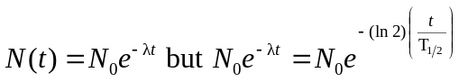
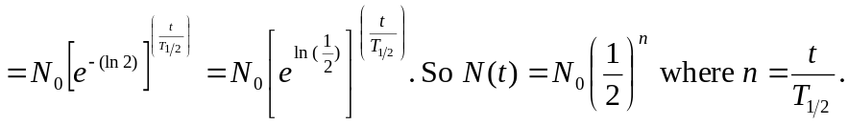
Recall

